Timbers HOA: Phase 1 (Brown Side)

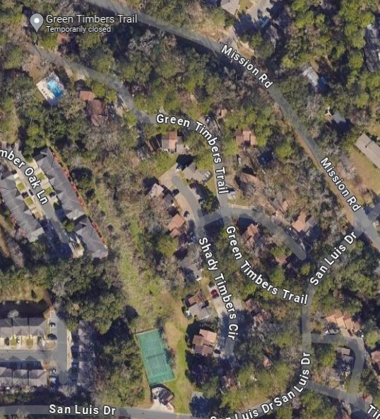
KEY
DUMPSTER
PET STATIONS

